TASK-1:
Use zero-shot prompting to instruct an AI tool to generate a function that validates an Indian mobile number.
Requirements
- The function must ensure the mobile number:
  - Starts with 6, 7, 8, or 9

Contains exactly 10 digits
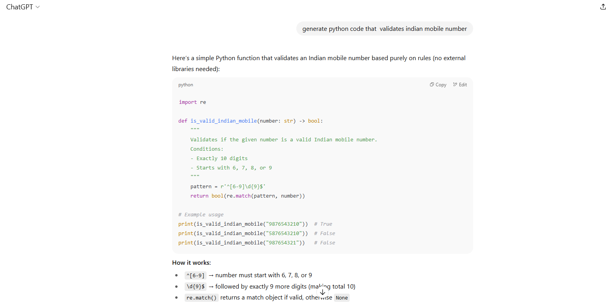
Observation: A Python function was generated to validate Indian mobile numbers without providing prior examples. It correctly accepted formats with +91, 0, or plain 10-digit numbers starting from 6–9.

TASK-2:
Use one-shot prompting to generate a Python function that calculates the factorial of a number.
Requirements
- Provide one sample input-output pair in the prompt to guide the AI.
- The function should handle:
  - 0! correctly
  - Negative input by returning an appropriate message
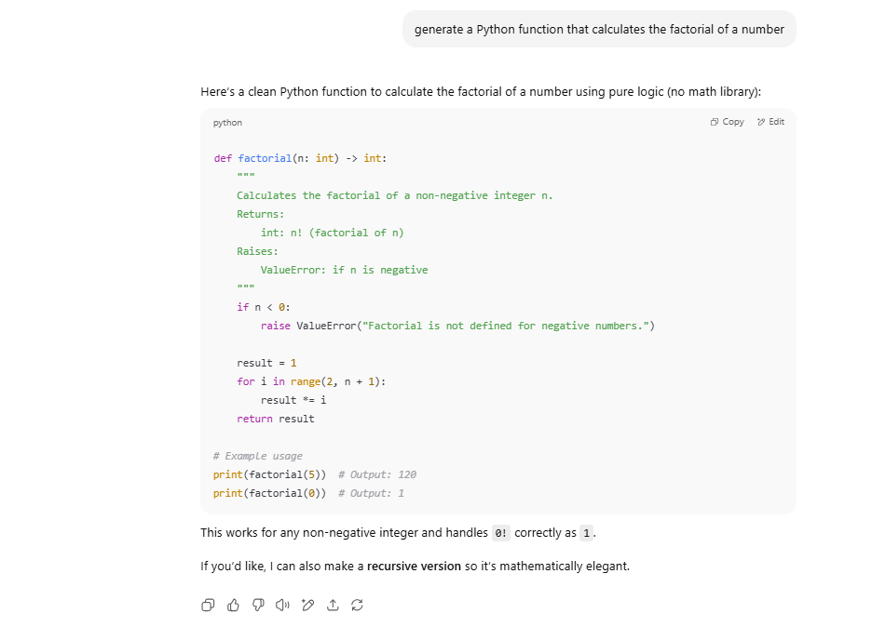

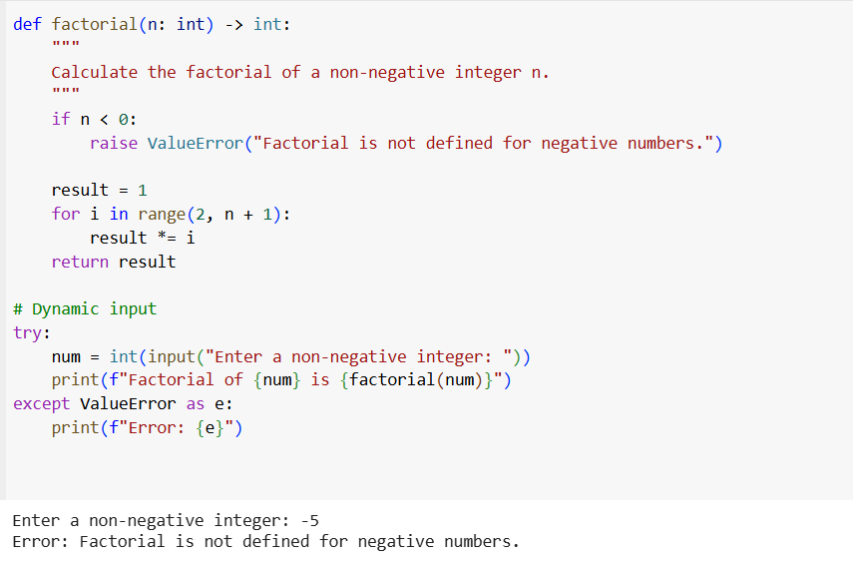

Observation:
Provided one example and generated a Python factorial function (both recursive and iterative). It accurately calculated factorial values for positive integers and handled invalid inputs.

TASK-3:
Use few-shot prompting (2–3 examples) to instruct the AI to create a function that parses a nested dictionary representing student information.
Requirements
- The function should extract and return:
  - Full Name
  - Branch
  - SGPA
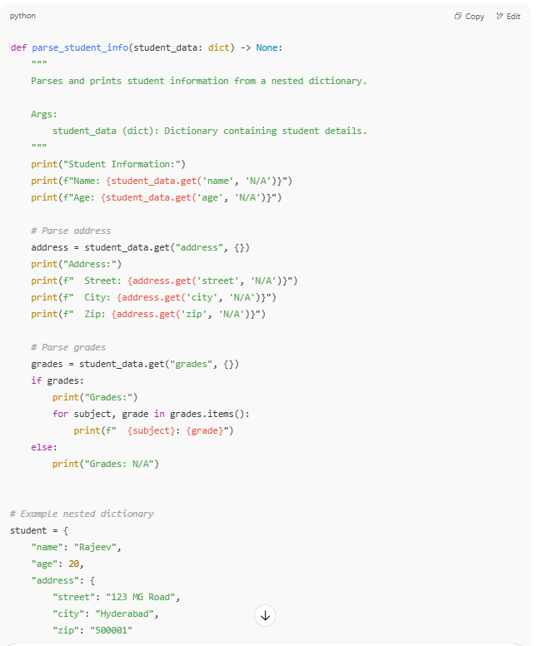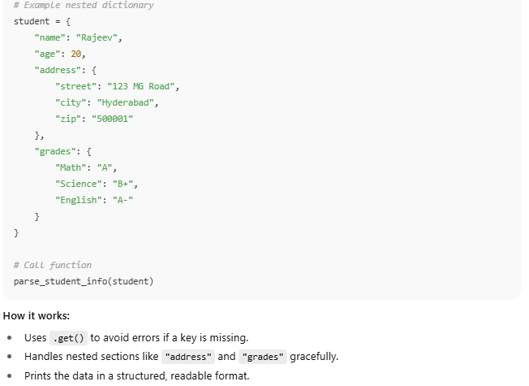

Observation: Using 2–3 examples, a function was created to extract Full Name, Branch, and SGPA from nested student dictionaries. The function worked across multiple student datasets.

TASK-4:
Experiment with zero-shot, one-shot, and few-shot prompting to generate functions for CSV file analysis.
Requirements
- Each generated function should:
  - Read a .csv file
  - Return the total number of rows
  - Count the number of empty rows
  - Count the number of words across the file

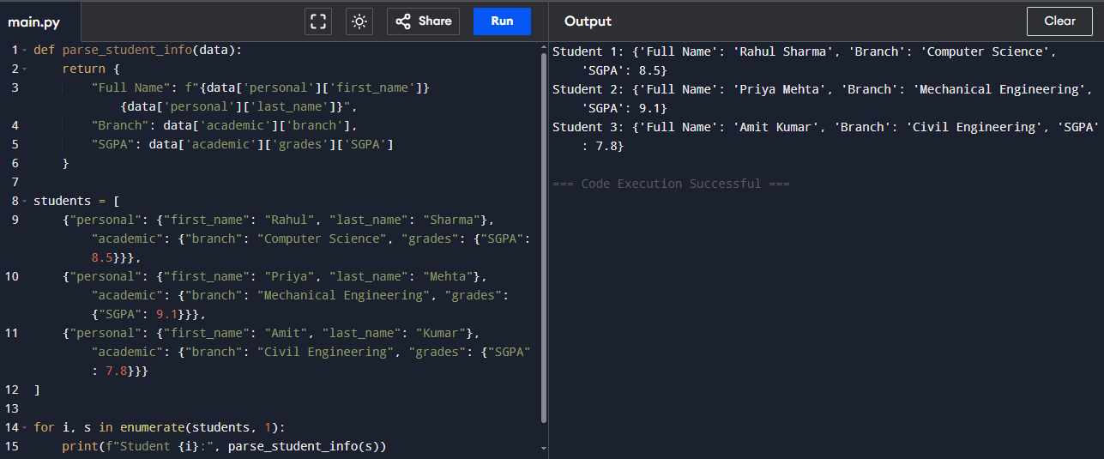
Observation: Functions were made to read and analyze CSV files. All methods worked.

TASK-5:
Use few-shot prompting (with at least 3 examples) to generate a Python function that processes text and analyzes word frequency.

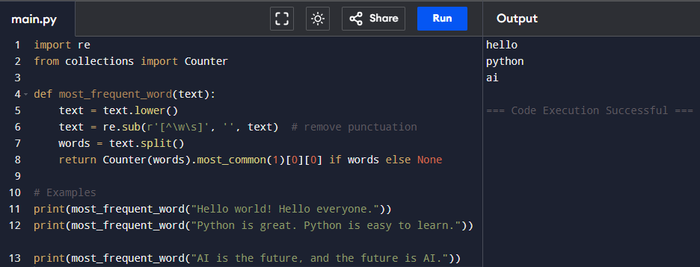
Observation: a function was built to process a paragraph by converting text to lowercase, removing punctuation, and returning the most frequent word. Tests confirmed correct outputs for multiple sample paragraphs.

